Dear Seller:
For an upcoming local campaign for our <Client>, <Agency> will be using Mediaocean’s Media Management Seller Workflow tool (PFS) for Local TV prebuy avails and negotiations. This will require that you use the RFP and proposal exchange workflow that PFS offers. If you are already signed up, that’s great. If not, it’s easy to create your FREE account.
Please follow THIS LINK to log into Prisma for Sellers (PFS).
Upon access to the link, you will see the screen below. Click on Request an Account if you don’t have one already.
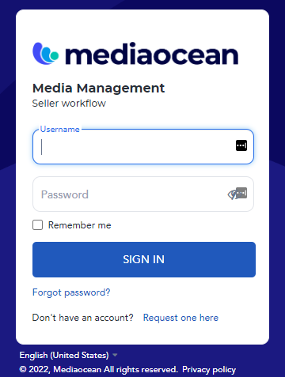

Complete the form below insuring that you select Local TV as the media type.
Once Mediaocean sets up the account, you will receive an email and will then be able to activate it in PFS by creating a password.
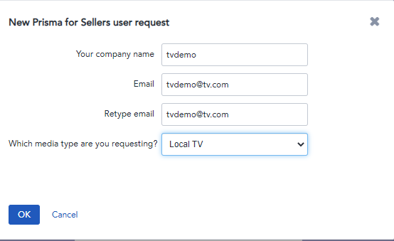

If your email address domain is already activated for PFS, a message will be displayed as shown in the screenshot below. By entering a message in the open text box and then SEND, the company account admin will be alerted that you require setup and communication should continue with your internal admin leads. Once your company admin sets up the account, you will receive an email and will then be able to activate it in PFS by creating a password.
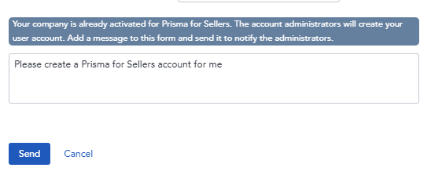
If the workflow above doesn’t apply to your email domain, then you will be brought directly to Step 2 below and proceed as follows:
The second form will ask for more details about your company, please enter AGENCY NAME (For example) as your referring agency. Once all required blue fields are filled out, press NEXT to complete the account setup.

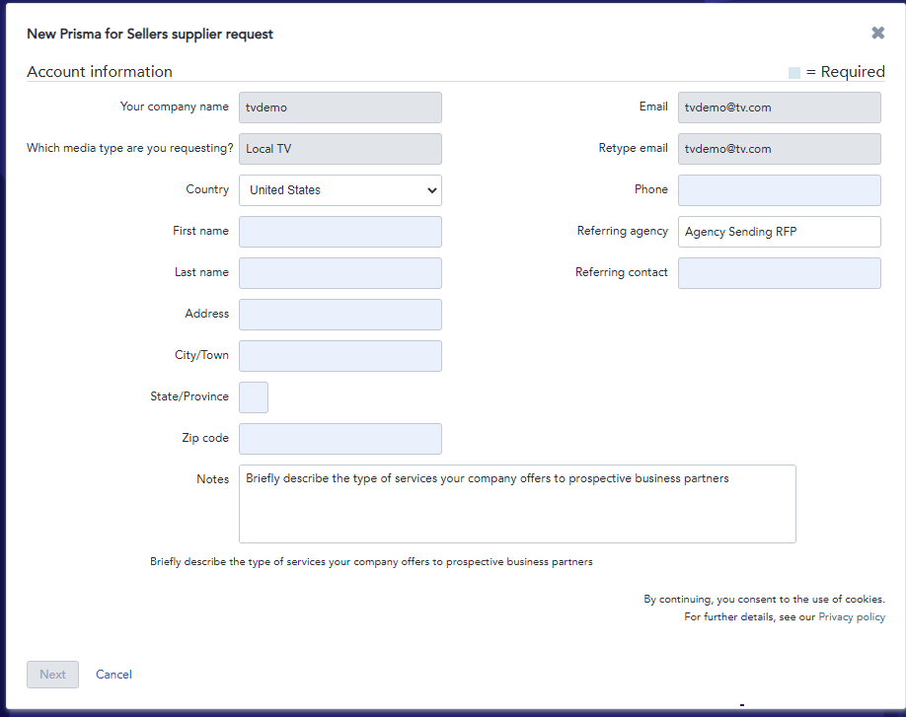

For all PFS Sellers:
Mediaocean offers online training webinars on using the PFS workflow that can be scheduled via the MO Training Calendar. Please sign up for a session. Please note the TV sessions specifically.
Documentation on the Mediaocean Seller Workflow tool can also be accessed using this Quick Cards link that is available on the Mediaocean Customer Experience site. Also, in application dynamic help is available once logged into PFS directly.
If you have any questions on PFS, please send an email to sellers@medioaocean.com and assistance will be provided.
The RFP email that you will receive from the buyer will also include a link to the PFS sign in page.
Please let us know immediately if there are any participation concerns.

Thank you,

