Hello!
We are excited to have you participate in the RFP for National TV with our agency. As an agency using Prisma, we strongly encourage you to use Prisma for Sellers (PFS).
Follow the information below and request your free account to use Prisma for Sellers (PFS).
Steps when requesting your free account:
- Navigate to the request page.
- Beneath the login area, click Request one here.

- Provide your name and email and select National TV.
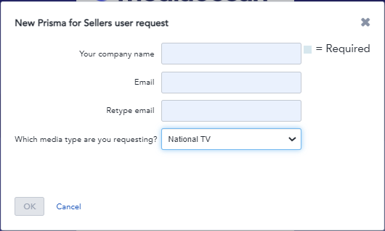
- Provide more details about you and your company; please enter our team as your referring agency.
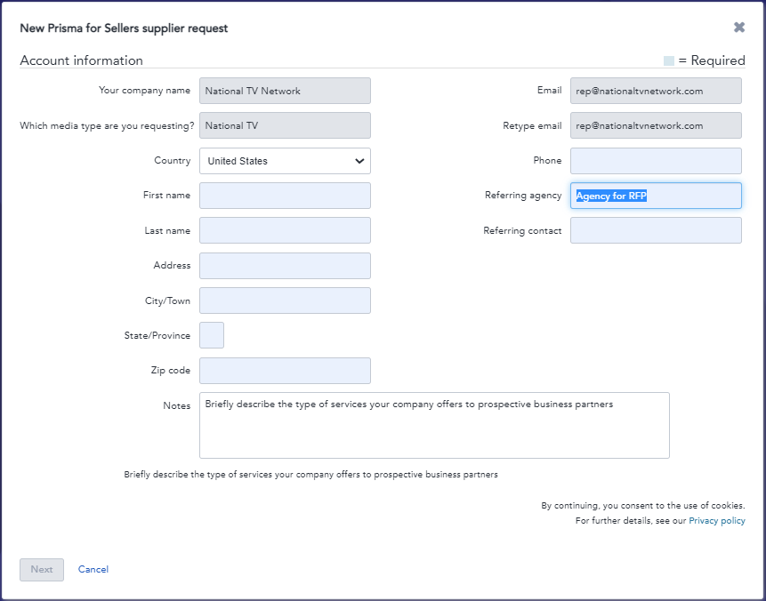
After your account is set up, you’ll receive an email to activate and customize your password for access.
Mediaocean offers a self-paced learning path as well as a quick learning video on the Mediaocean Customer Experience site, in addition to the dynamic help available once logged into PFS. If you have any questions on PFS, please send an email to Sellers@mediaocean.com and assistance will be provided.
We look forward to working together.

